1)
C
B
AVA
S
S
TVA
TVA
S
TVA

Letter ____ represents line TS or TS.
Letter ____ represents ray TS or TS.
Letter ____ represents line segment TS or TS.

2)
B
A
D
C

Letter ____ represents obtuse angle.
Letter ____ represents right angle.
Letter ____ represents straight angle.
Letter ____ represents acute angle.

3)
B
A
C
D

Letter ____ represents a regular pentagon.
Letter ____ represents an irregular pentagon.
Letter ____ represents a convex pentagon.
Letter ____ represents a concave pentagon.

4)
B
C
A

Line 2
Line 1
Line 1
Line 2

Letter ____ represents Line 1 is parallel to Line 2 or Line 1 II Line 2.
Letter ____ represents Line 1 is perpendicular to Line 2 or Line 1 I Line 2.
Letter ____ represents 2 intersecting lines.

Angles

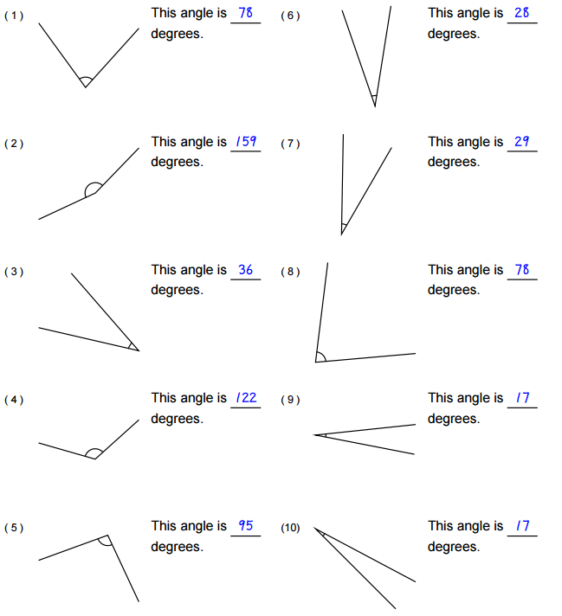

Identifying Triangles

Tick the boxes that apply to each angles
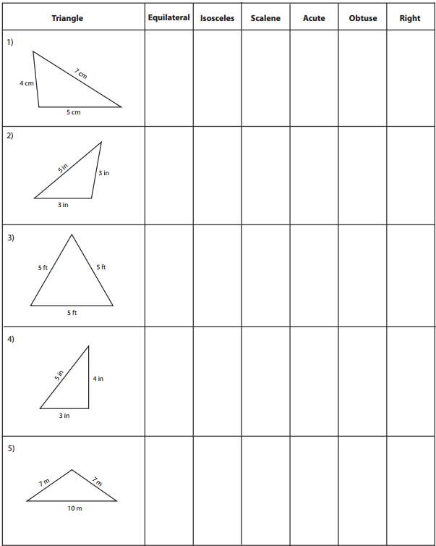

Find the unknown interior angle for each triangle

